**Interview Checklist**

|  |  |
| --- | --- |
|  | Short description (2-3 sentences) of your documentary |
|  | Pen and paper for note taking |
|  | List of questions to ask your subject |
|  | Mic (lav mic or mini-shot gun) and connecting cables |
|  | Headphones |
|  | Camera |
|  | Charged battery and charging equipment, just in case. |
|  | Tripod |
|  | Any lighting equipment you plan to use |

# DIY Lighting: Taking Advantage of Natural Light

Although professional light kits are great for creating a well-lit interview setting, it can also be difficult, time-consuming, and costly to set up and sometimes completely unnecessary. Using **natural light** effectively is a great alternative to expensive and bulky light kits. Relying on natural light requires you to study your surroundings, but it helps your production in many ways.

**Why Do We Light?**

* To see a picture
* To create a mood
* To highlight a person or object
* To mimic a time of day
* To create depth

**Learning About Light**

Every light source (sun, sky, lamp, candle, etc.) has its own character or quality. For example, a person on a sunny day looks different from the same person under an overcast sky. The difference in light quality affects the kinds of shadows cast on the subject. The light can be described as **hard** or **soft**. The hardness or softness depends on the distance from the subject and the size of the light source. **The closer the light is to the subject, the stronger or harder the light will be.**

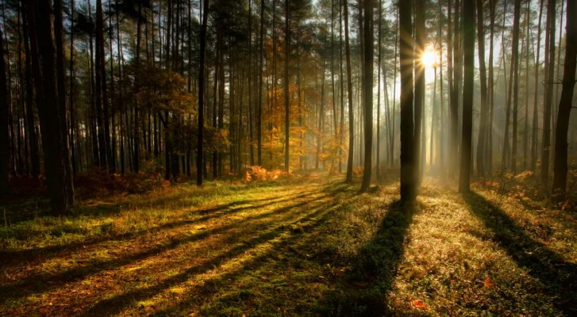

**The color, direction, quantity, and quality of the light you use determines how your subject appears**. With professional light kits, you can control these effects, however, using natural light, you will have to be mindful of how daylight and sunlight change throughout your shoot. Changing daylight can alter the apparent shapes, colors, tones, and forms of a scene. The color of light changes most rapidly at the extreme ends of the day or during weather changes, such as storms or haze. The shape and direction of shadows are altered as the light changes directions throughout the day. You can tell that the image above was taken in the late afternoon because of the orange color of the light and the low placement of the sun, which is creating the tree’s long shadows. The sun rises in the east and sets in the west, which means the sun will create different shadows as it moves across the sky throughout the day.

**Front Lighting**:

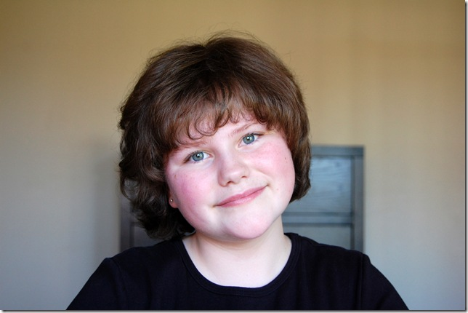This is the type of lighting that is created when the sun is in back of the videographer, facing your subject. The image on the left is an example of front lighting. Although having the light face your subject is better than having the light behind the subject, it isn’t necessarily the **best** lighting solution. It does nothing to bring out detail or provide an impression of depth. To give an impression of form, depth, and texture to the subject, you should ideally have the light come from the side or at least and angle.

**Side Lighting**:

Interesting effects can be achieved by changing the angle of the light falling on your subject. Side lighting means that your subject is being lit from a side angle. With side lighting, the light is not directly in front of your subject, but is slightly to the side, creating more shadows and giving your subject texture.

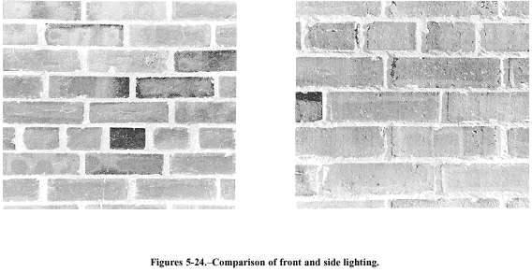

Look at the brick wall above first in direct front sunlight and then in side lighting. Direct, front sunlight shows the pattern of the bricks and mortar in a flat, uninformative way, but side lighting creates shadows in every little crevice.

**Backlighting:**

If the sun is in front of the videographer, coming directly at the camera, then your subject is **backlit**. Backlighting is often used to produce a silhouette effect and creates lens flare. **In most cases, you do not want your subject to be backlit - it is best to avoid backlighting.**

**Fluorescent Lighting:**

Indoor scenes illuminated by fluorescent lights usually appear pleasing and natural in real life; however, images of these same scenes often have an overall color cast that makes them appear unnatural. Fluorescent lighting often causes dark shadows under the subject’s eyes. These shadows cause the eyes to appear dark and sunk in.  **When possible, it is best to use natural light rather than indoor fluorescent lighting.**

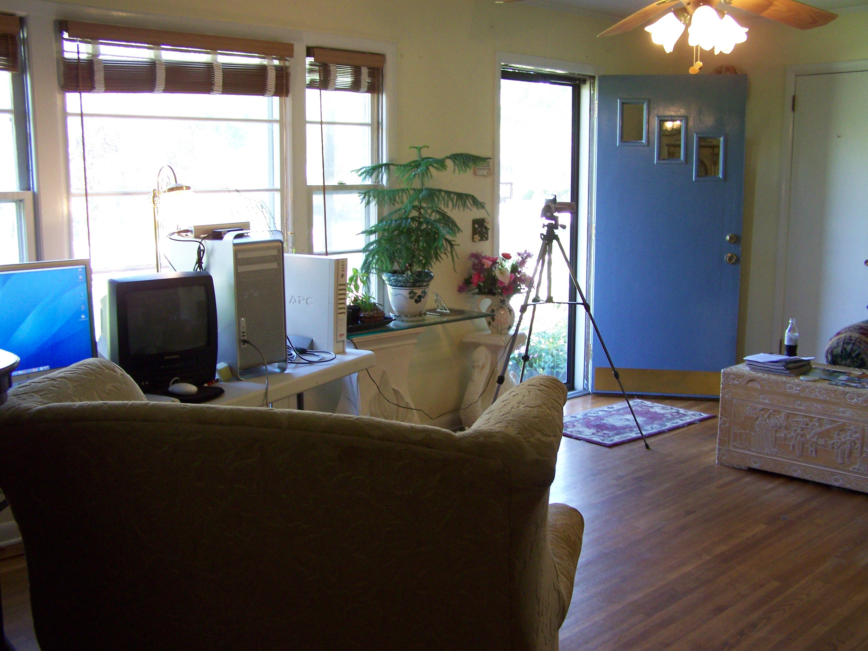**Ideal Lighting Set Up:**

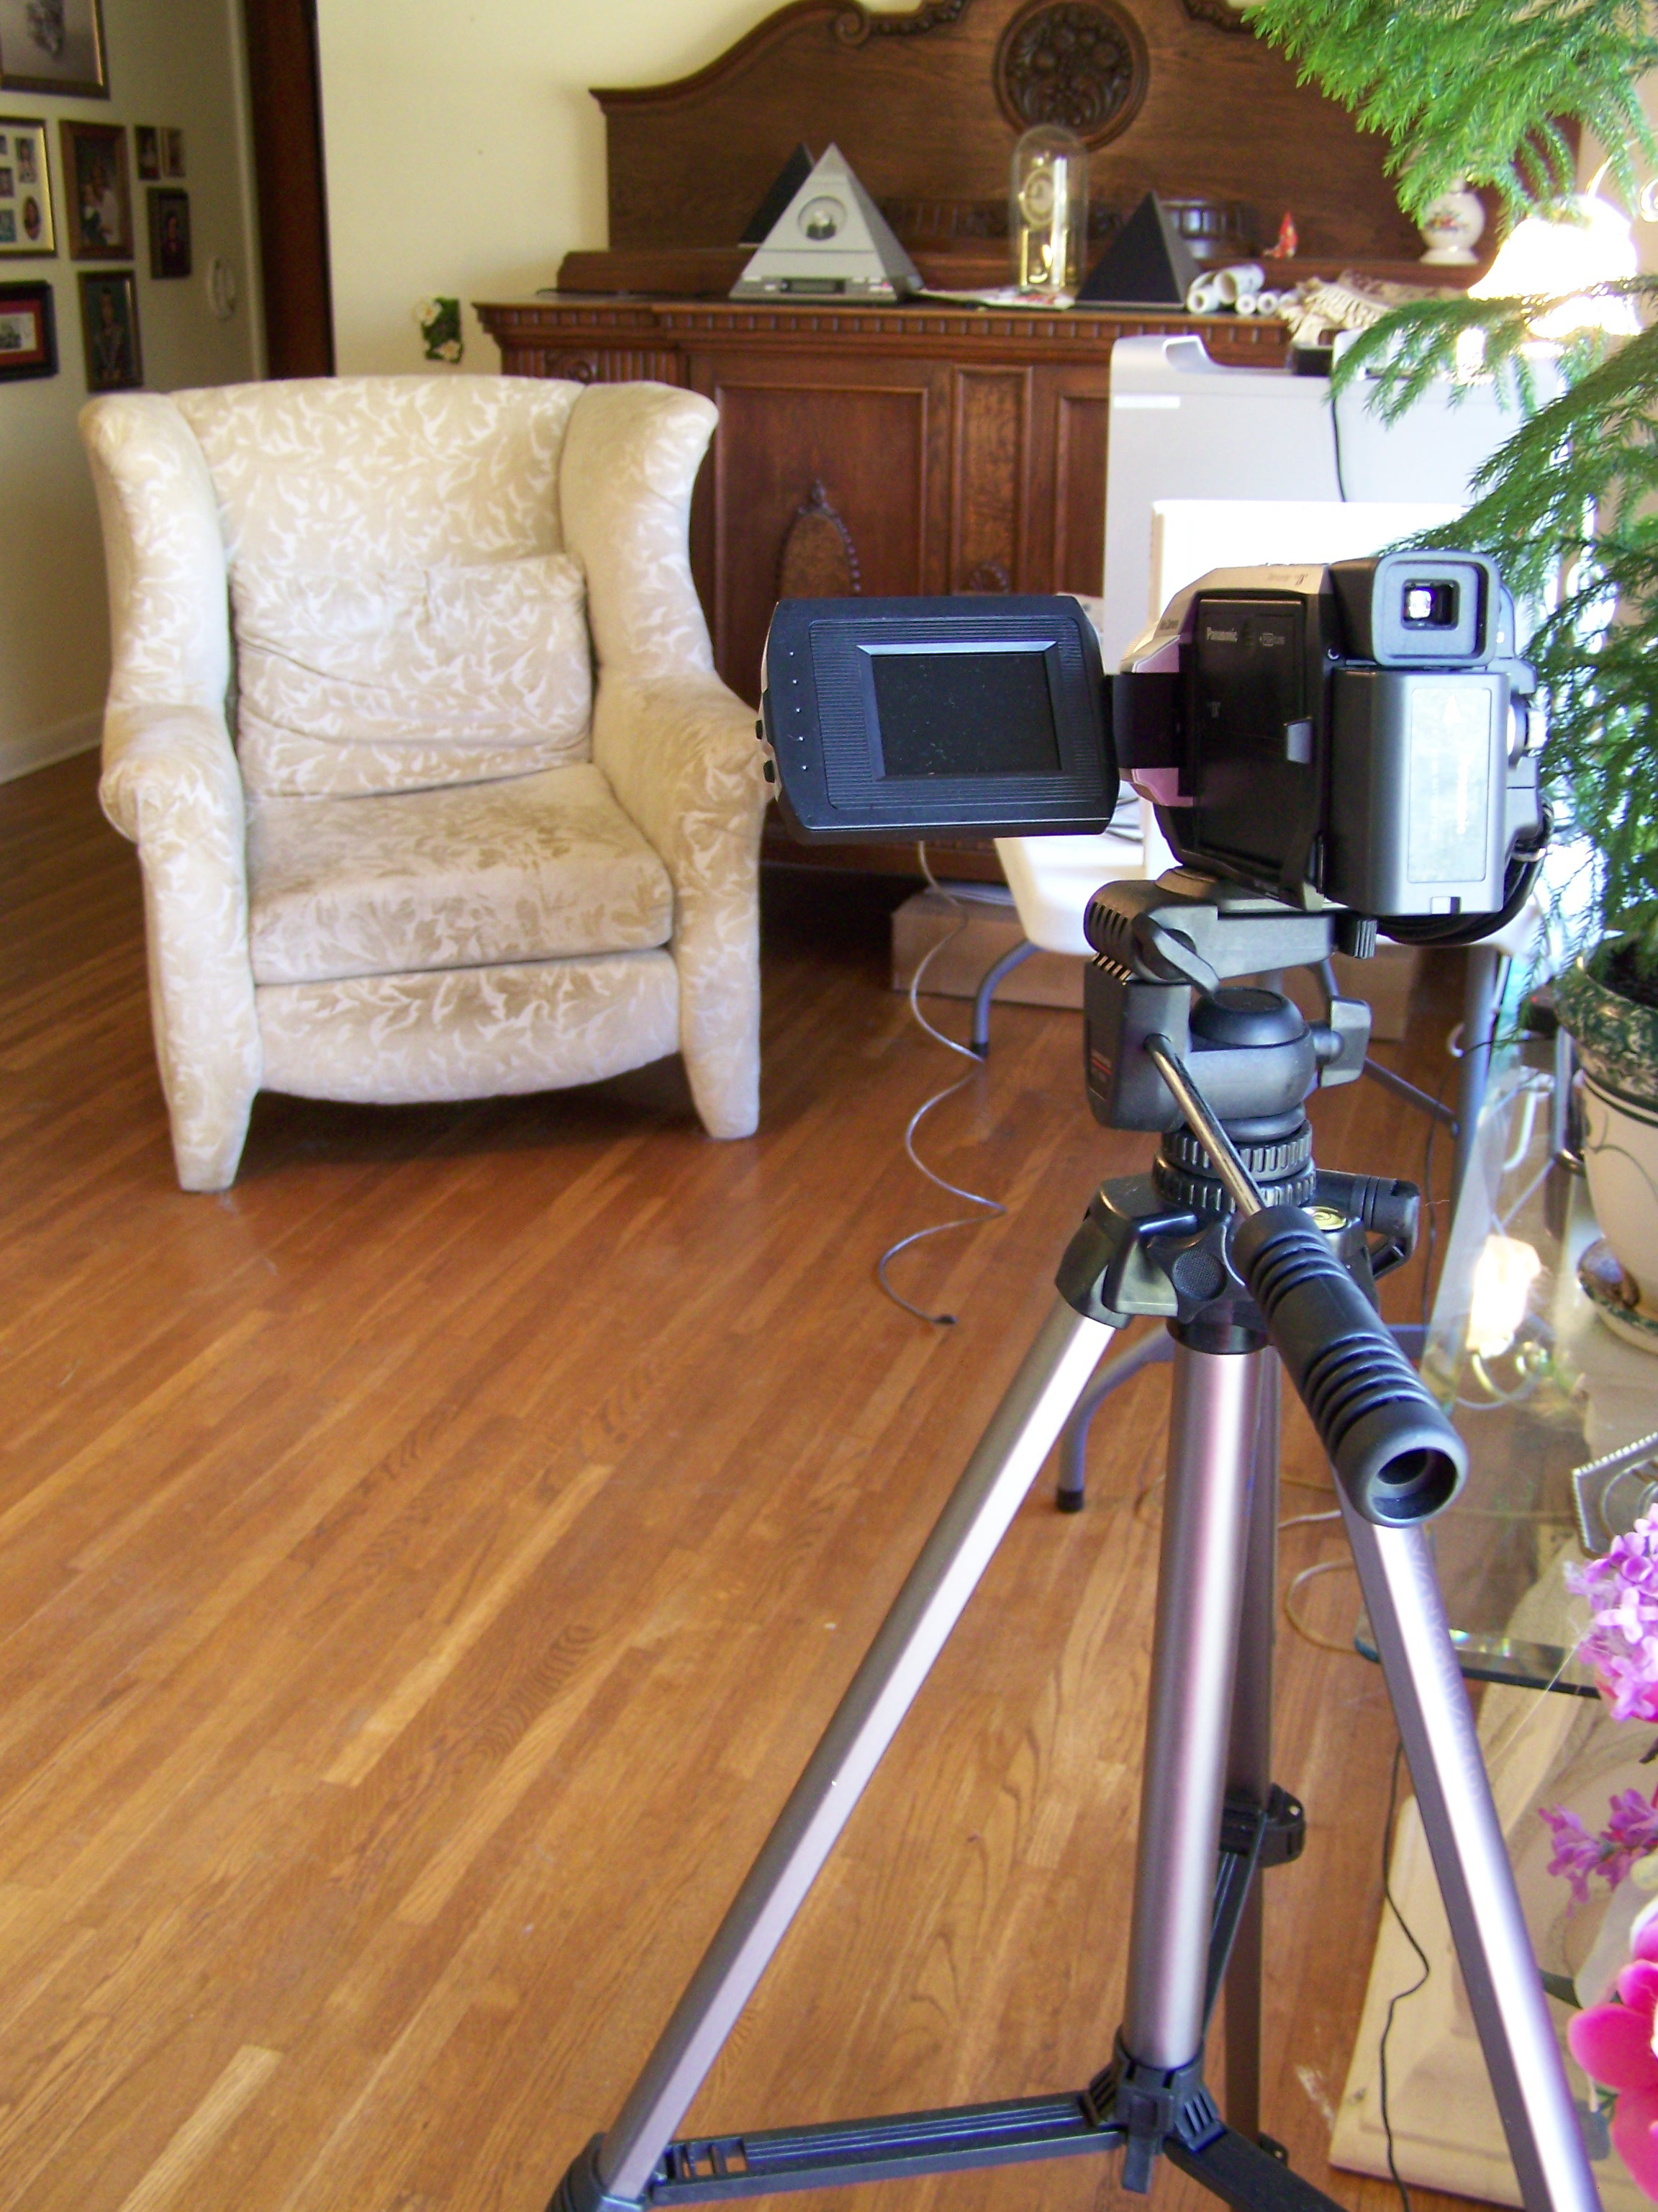

In the images above we see the back and front view of an interview set up using natural light. The window blinds were raised and the door was opened so both could be used to their maximum lighting capacity. Once the window and door are cropped out of the picture, the light falling on the interview subject (chair) is nice and bright.

**The light source should always be behind or to the side of the camera.** The light should be on your subject, not behind them.  Put your subject near the window where the light falls on them, not behind them.  As you can see from the pictures of the interview, the chair is placed close to the window so the light falls on the person’s face.  The window is to the SIDE of the interview subject.

**Sound Basics and Recording Techniques**

**Sound:**

Sound is an invisible vibration. It travels in waves, spreading outwards from the source of the sound. Sounds are different both in loudness and pitch, often known as frequency. Loudness is measured in decibels (dB).

Pitch / Frequency is measured in Hertz (Hz). All sounds are made up of different frequencies. We can describe this as the pitch of a sound. The frequency of a sound affects the pitch that it is heard at. The sound a whistle makes when it’s blown is a an example of a high frequency pitch whereas the noise made when banging on a drum is an example of a low frequency pitch.

**Not only is sound half your video, but sometimes sound makes or breaks a video.**  **It is important to know how to record sound technically, and then also how to listen for sounds that can work creatively to enhance your story.**

**Types of Audio You Will Be Recording:**

Generally, sound for your video will include the following: Dialogue or Voice Over, Ambiance, Sound Effects and Music. You will need to record all of this audio and then assemble your sound design (what kinds of audio will be part of the video sound) and then refine your sound mix (the levels each audio element will be heard in general and in relation to each other).

**Selecting the Proper Mic:**

Use an external mic whenever you can. This lets you have more control over how and what you record. Microphones come in a variety of types. They can be direction or omni-directional, have their own battery source or require power from the camera etc. In addition, each make and model has its own character. **With any mic, always listen with headphones to confirm you are recording the sound you want. You can always reposition the mic to get what you want!** Connect each type of mic to the camera and listen to what audio is picked up.

**Lavalier Mic (Lav)**:

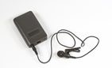

**Typical Use:** Interviews

**Characteristics:** These are the small “bud” microphones that can fasten to clothing. Although these mics are “omni-directional”, they are specially designed to pick up the voice vibration/sounds of a person speaking.  It does not matter where the Lav is placed, as long as it is in the general chest area (collar or front of shirt).

**Tips**: Try to hide the lavalier or at least the wire under the clothes.  (If you hear a rustle through the headphones, the lavalier chord may need to be taped to the person's skin.)  Place as close to the sternum as possible. A lavalier likes to hear the resonation in the chest cavity.

**NOTE**: Each interview subject needs his or her own lav mic. If you have more than one interview subject and only one lav mic, use a shotgun mic on a boom pole instead and move the boom accordingly.

**Shotgun Mic (also known as boom or stick):**

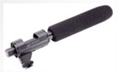

**Typical Use:** Multiple Interview Subjects, Specific Sound, Ambient Sounds,

**Characteristics:** Shotgun mics are usually much more sensitive than an on-camera mic, and pick up better sound.  Shotgun mics are directional mics and usually pick up sound in the direction the mic is pointed. Where you point the mic matters!

**Tips**: For interview: Aim the shotgun mic like a gun directly at the subject.  Bring the mic in as close as possible to the subject using a boom pole, pistol grip or stand. Overhead is usually safest, though sometimes from under the subject is preferable, depending on the framing of the shot. Be sure the mic is pointing in the same direction as their path of speech- not to their nose or to the side.

To record general sounds with a shotgun mic, since the mic is directional, aim the mic in the direction of the sound you want to forefront. For example, if you are at a park and there are kids playing to the right and a fountain to the left, the side you point it to will highlight one sound over the other (to the right you will hear more of the kids, to the left, more of the fountain, upright a combo of both and whatever is in the sky).

**NOTE**: If you are recording general ambiance, if you have access to an external omni-directional mic, use that. If not, you can cheat it with a shotgun, by pointing the shotgun in a direction in between sounds and listening with headphones to see if you get what you want.

**On-Camera Built In Mic:**

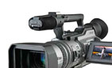

**Typical Use:** Used to record audio when there is no external mic.

**Characteristics:** Omni-Directional.

**Note**: Since this mic is omni-directional, it picks up sounds from all around, sometimes including the hum of the camera. If you have access to an external mic, it is always better to use the external mic so you can have more control and discretion for the audio you record.

**Recording Sound Techniques**

**Basic Checks:**

1. **Are you in a relatively quiet place (especially if conducting an interview)?**
2. Is your external mic properly connected to the camera?
3. Is the external mic power on (and the camera extra source power off)? Or vice versa. Select one power source so you do not short circuit the camera or mic with multiple power sources!
4. Are your audio levels set? Is the audio level high enough, but not in the red?

**Note:** If you are interviewing someone, set up all your equipment and then have your subject say a few sentences so you can meter your level and set the audio levels to match the level of their voice. Then, start recording the interview. Use your eyes and ears! Watch for the boom, microphone, shadow, or boom operator in the shot! It helps to show the boom operator where the edge of the frame is. Also, while shooting always be monitoring the sound. If this person closes his or her eyes, or looks away from the scene, it may help him or her to concentrate on the sound. Listen especially for excessive sound.

**Excessive Sounds:** Sometimes there are sounds in the setting in addition to what you are trying to record. Sometimes this is ok, other times this is distracting. Listen to the situation and if it will be too distracting, move your location or wait until the sound stops.

**Some “excessive” sound elements to listen for:**

Bus Lines/Traffic construction; Hum of Computers/Refrigerators; Street Noise; Ventilation Systems; Garbage/ Recycling Activity; Fluorescent Lights; Airplanes; Traffic; Actual space: Echo, Dead or Live; Wind

**Record Room Tone / Ambient Sound:**

**Room tone** is the sound of your location when all the subjects and crew hold still and silence is recorded. It has a sound to it.

**Ambient sound** is the same thing, but more commonly refers to outdoor sounds, the background sound of your location.

**Always record at least 30 seconds to one minute of these** without cast or crew making any noise, but remaining on location.

**Blank audio tracks do not sound the same as silence!**  In editing you may need these crucial audio clips to replace unwanted sounds or fill in “sound gaps” in your edit.

**Note about Ambient sounds:**

Are there other ambient sounds in the environment you could record that may be used as part of your sound design later?

**Final Cut Express Basics**

**Organizing your files in FCE**

1. First, create a folder on your desktop with your name. With no programs opened, go to the top left corner and click on **File > New Folder**. A folder will appear on your desktop, and you can type your name in the box provided.
2. 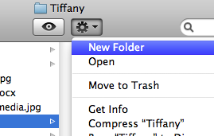Now you are going to create another folder inside your new folder for music and/or additional videos you want to add to your final cut project. **Double-click** on your newly created folder and a dialog box will pop up. Click on the asterisk shaped icon at the top of the box and select new folder. Name this folder “**Extra Files**.” Anytime you add a file to your final cut project that isn’t coming **directly from your camera**, you will need to first place it into this folder and then import it into final cut.

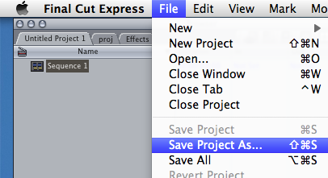

1. Open **Final Cut Express**. On the top left corner, click on **File >** **New Project.**  Then select **File > Save Project As…**. A dialog box will pop up asking you where you would like to save your project. Select **Desktop** > **(Your name) folder** and click **Save** on the bottom right hand corner.
2. 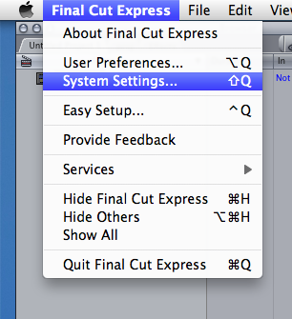Now you will set your scratch disks. **This is very important** – if you do not save your scratch disks correctly before you begin your project, you can run into problems later. This time go to the top left corner and select **Final Cut Express > System Settings**.
3. A dialog box will automatically open to the tab that reads “**Scratch Disks**.” Select the **Set** button in the first row and a dialog box will pop up prompting you to save your scratch disks to a folder. Select **(Your name) folder** and press **Choose** on the bottom right hand corner of the dialog box. Now, you will do the same for the **Waveform Cache, Thumbnail Cache,** and **Autosave Vault** by pressing **Set** and selecting **(Your name) folder** for each one. When you have finished, press **Ok** at the bottom right hand corner.
4. Now you are ready to begin editing!